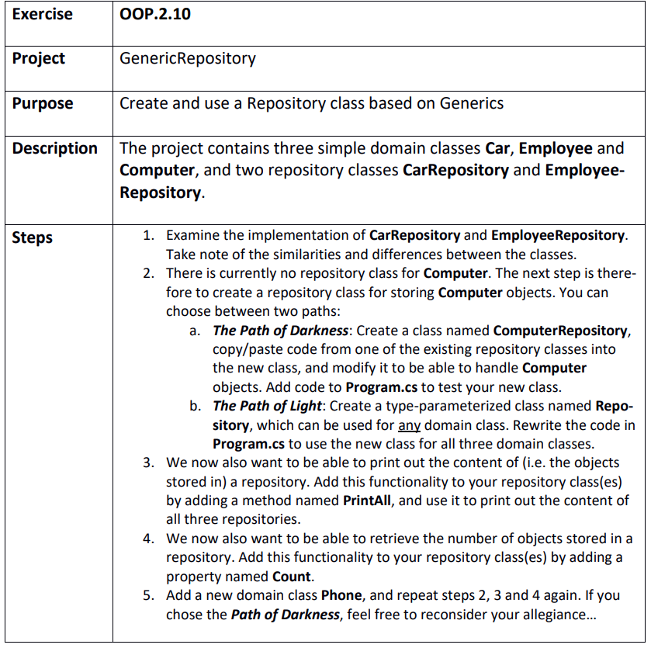

Step 1
C:\Git\OOProg25\Chap\OOProg02\MySolution\OOP.2.10 - GenericRepository\GenericRepository\GenericRepository.sln

Step 2

a)
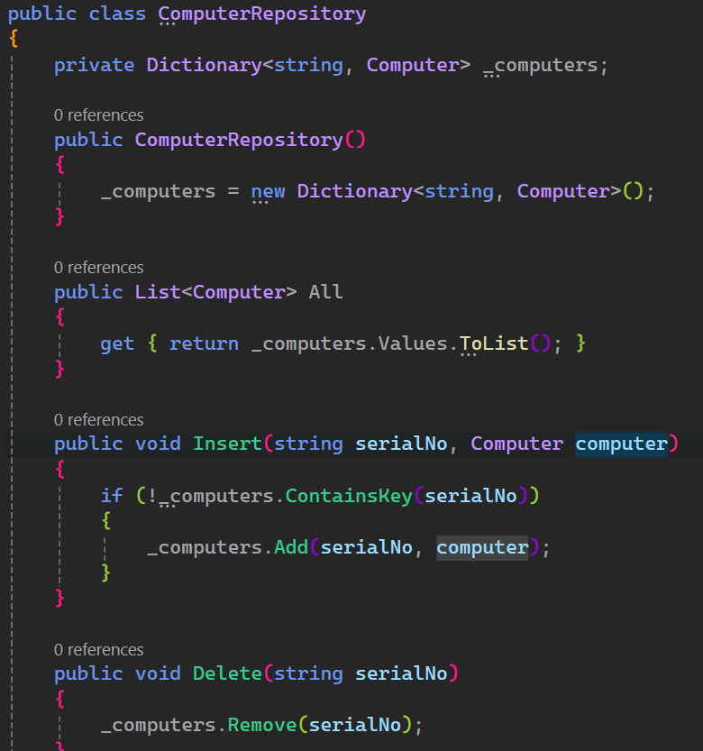

b)
